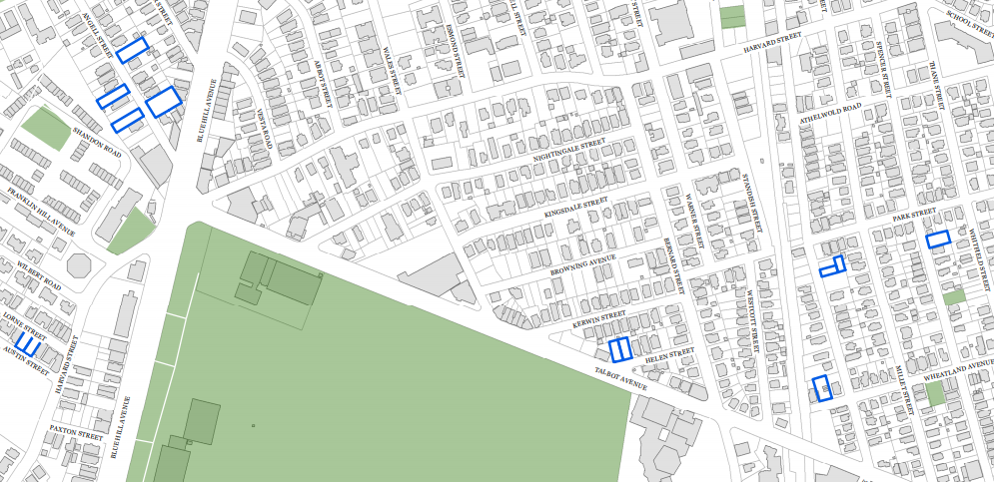
9

8
7
6
5
4
3
2
1

ANGEL SPENCER PARCEL MAP

NUMBER | STREET ADDRESS | PARCEL NUMBER | Sq. Footage
1. | 21 Angell Street | 1404224000 | 10,000
2. | 37 Angell Street | 1404229000 | 6,625
3. | 28 Angell Street | 1404256000 | 5,420
4. | 22 Angell Street | 1404259000 | 5,398
5. | 12 Lorne Street  14 Lorne Street | 1404296000  1404295000 | 3,214  3,214
6. | 17 Helen Street  19 Helen Street | 1402219000  1402220000 | 3,770  3,765
7. | 115 Wheatland Avenue | 1700330000 | 5,500
8. | Unnumbered Norwell Street  & 242-244 Norwell Street | 1700345000  1700347000 | 2,188  2,211
9. | 78 Spencer Avenue | 1700418000 | 4,612

