Thursday, March 19, 2020
Beacon Hill Architectural Commission
Public Hearing

Property Address: 16 Beacon Street, Boston, MA 02108
Property Owner: Boston Bar Foundation, 16 Beacon Street, Boston, MA 02108

Talking points:
We are requesting an exemption to allow proper venting of the replacement boiler so that heat can be restored to the basement and other parts of the building. We are currently operating without a boiler and are having to rely on temporary heaters.
The 20+ year old boiler, located in the front of the building’s basement, was removed in preparation to install the new boiler. The Boston Bar Association was informed, by the master plumber overseeing the project, that the existing vent is no longer a viable option. The new boiler will require venting to the front of the building with a 5-inch circular vent with bird screen per 12.6.4.1 guideline for venting of appliances. The existing boiler was vented through a 200-year-old four story chimney that joins the neighboring eight story building's chimney at 14 Beacon Street and is no longer an option based on current plumbing codes. Sealed combustion requires specific types of vents and can only be installed per the Lochinvar boiler manufacturer’s manual. See attachment A - from manufacturer’s manual: “This appliance requires a special venting system. Use only approved stainless steel, PVC, CPVC or polypropylene pipe and fittings listed in Tables 3D, 3E, and 3G for vent pipe and fittings. Failure to comply could result in severe personal injury, death, or substantial property damage.”
This required vent would be visible to the public from Beacon Street and Bowdoin Street. There were no other viable options. There are limitations with running the flue to the four-story roof because of the neighboring building’s operative windows. There is a maximum 100-foot distance for a flue from the boiler. Each elbow will reduce the run by 5 feet. We looked at options to vent at the parapet. Unfortunately, the size of the pipe is too large to run through the studs in the wall. Running the vent pipe boxed in against the interior wall isn’t possible since a heating unit runs along that interior wall.
The application included the information sheet regarding venting of appliances (attachment B, section 12.6.4.1) regarding chimneys. In addition, the spec sheet for installing the vent with bird screen was included. The venting would come up from the basement, through the interior walls, to vent out on the left front side of the building between the first and second floor at the same level as the Y shaped copper drain. The manufacturer requires that the vent be 12 inches off the ground, see attachment A: “Vent = 12 equivalent feet (3.7m) minimum / 100 equivalent feet (30.5m) maximum”. Because of snow, Massachusetts requires that the vent be a minimum of 36 inches from the ground. We proposed placing the vent higher up where the copper drain forms a Y shape rather than directly above the Chester Harding sign on the building. The vent would be black polypropylene with a black plastic bird screen. The 5-inch circular plastic vent will stick out of the wall 3 inches.
The brick would be cut to allow for the vent to protrude. The mortar around the vent will be mended using the same mortar used when the building was repointed at the end of 2018.
In summary, we are without a boiler and looking to expeditiously restore heat to the back of the building and to the basement. Thankfully, the weather has worked in our favor with mild temperatures. The remaining step to completing the boiler installation is the venting. Obtaining approval from the Beacon Hill Architectural Commission is the final step for us.

Front of 16 Beacon Street
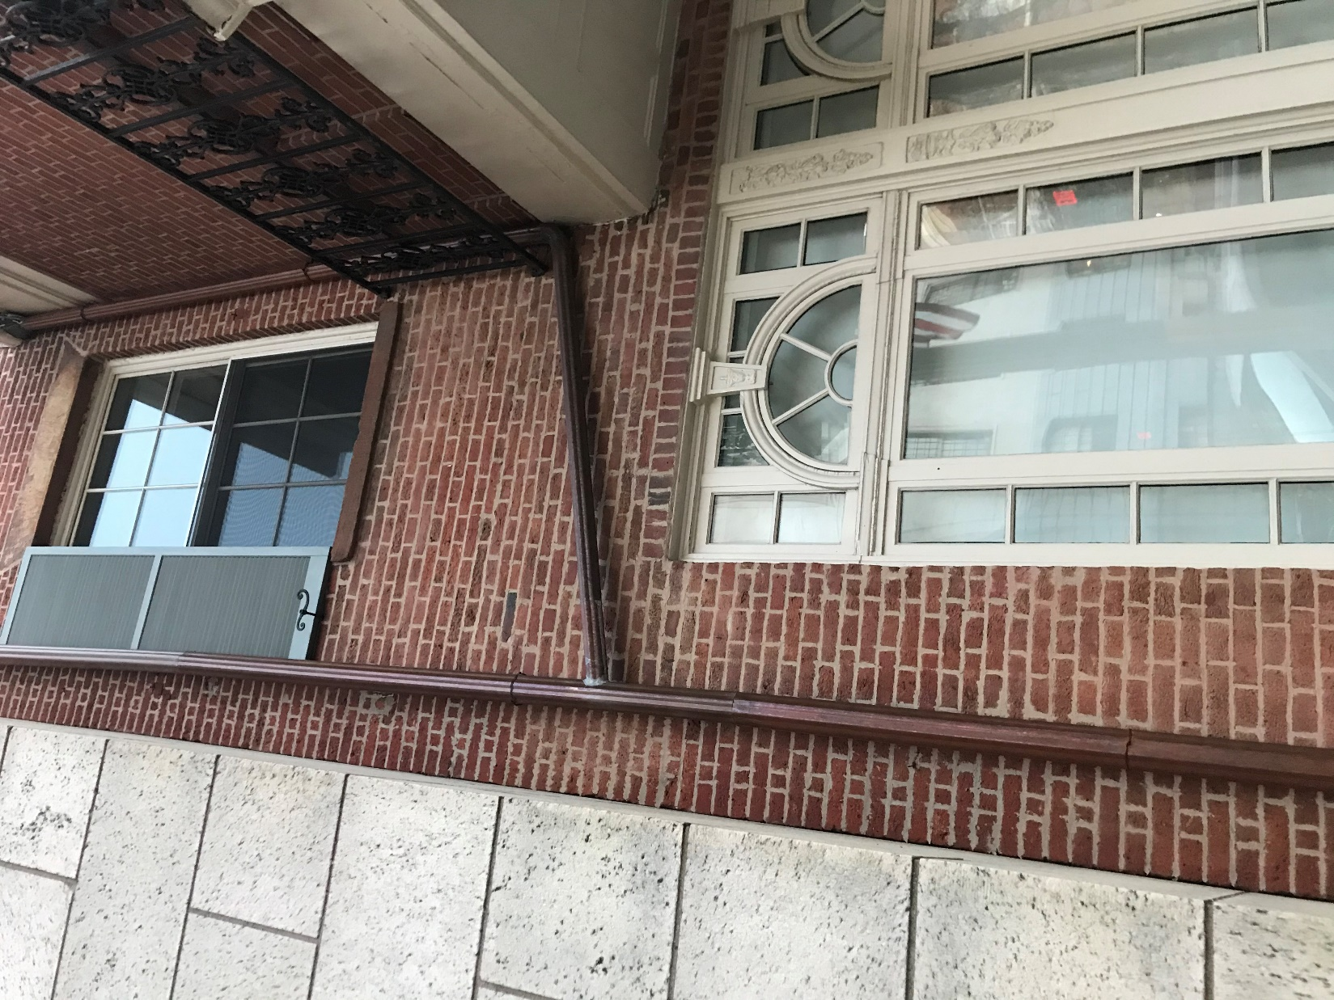
Y shape drain pipe
Chester Harding sign above flower box
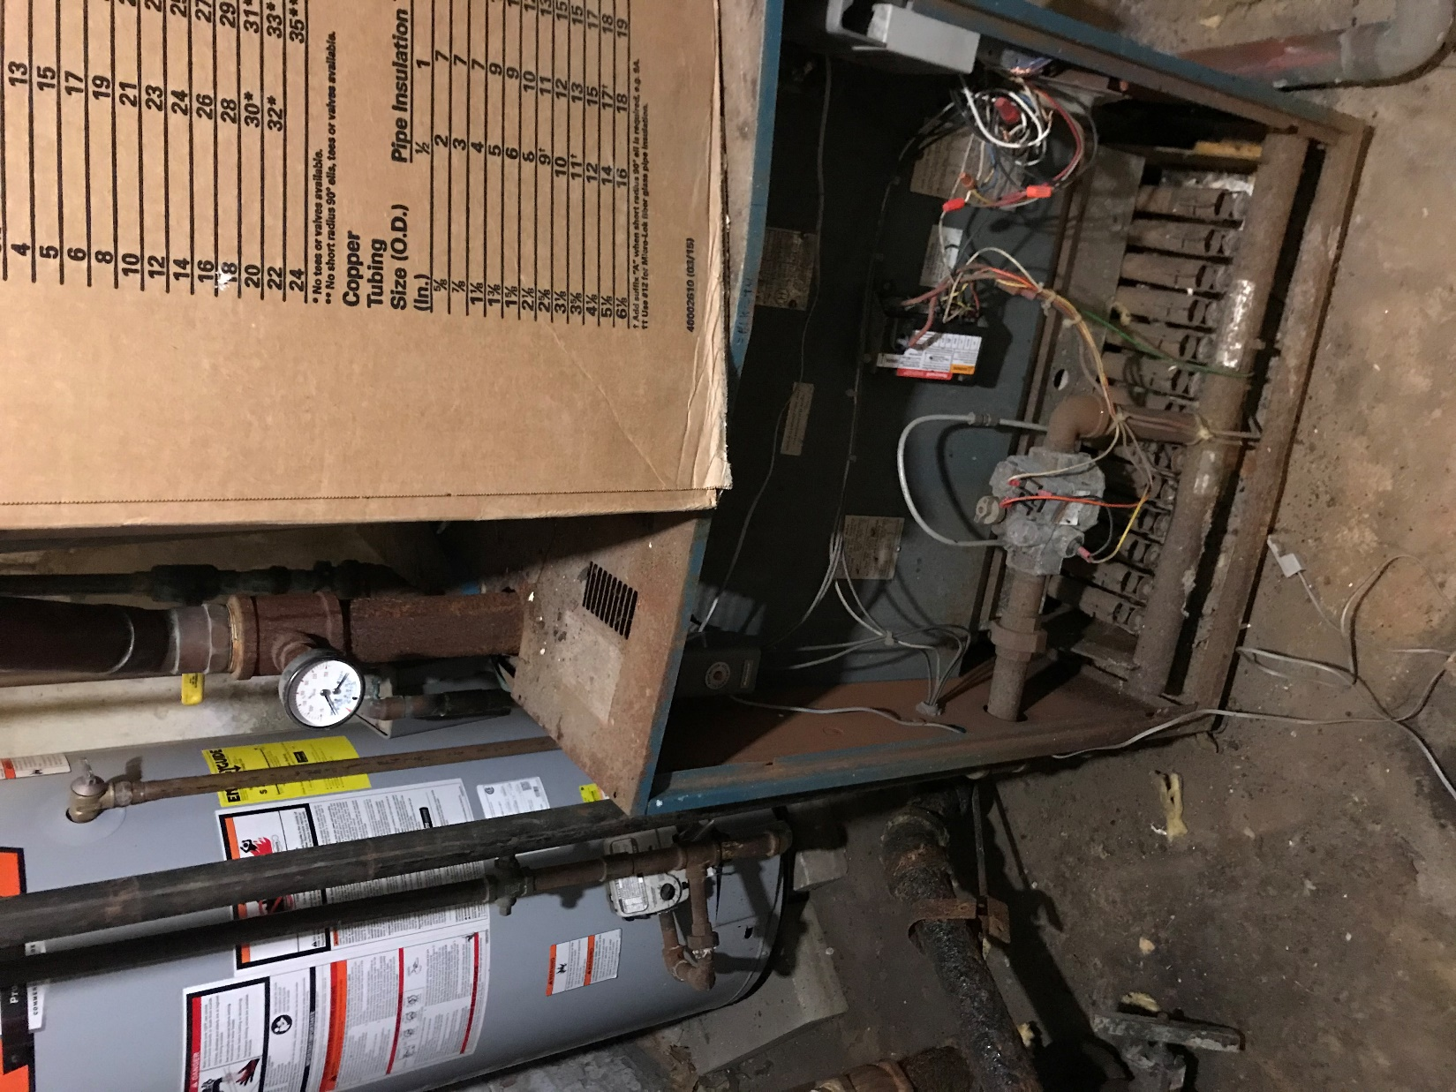
Old boiler
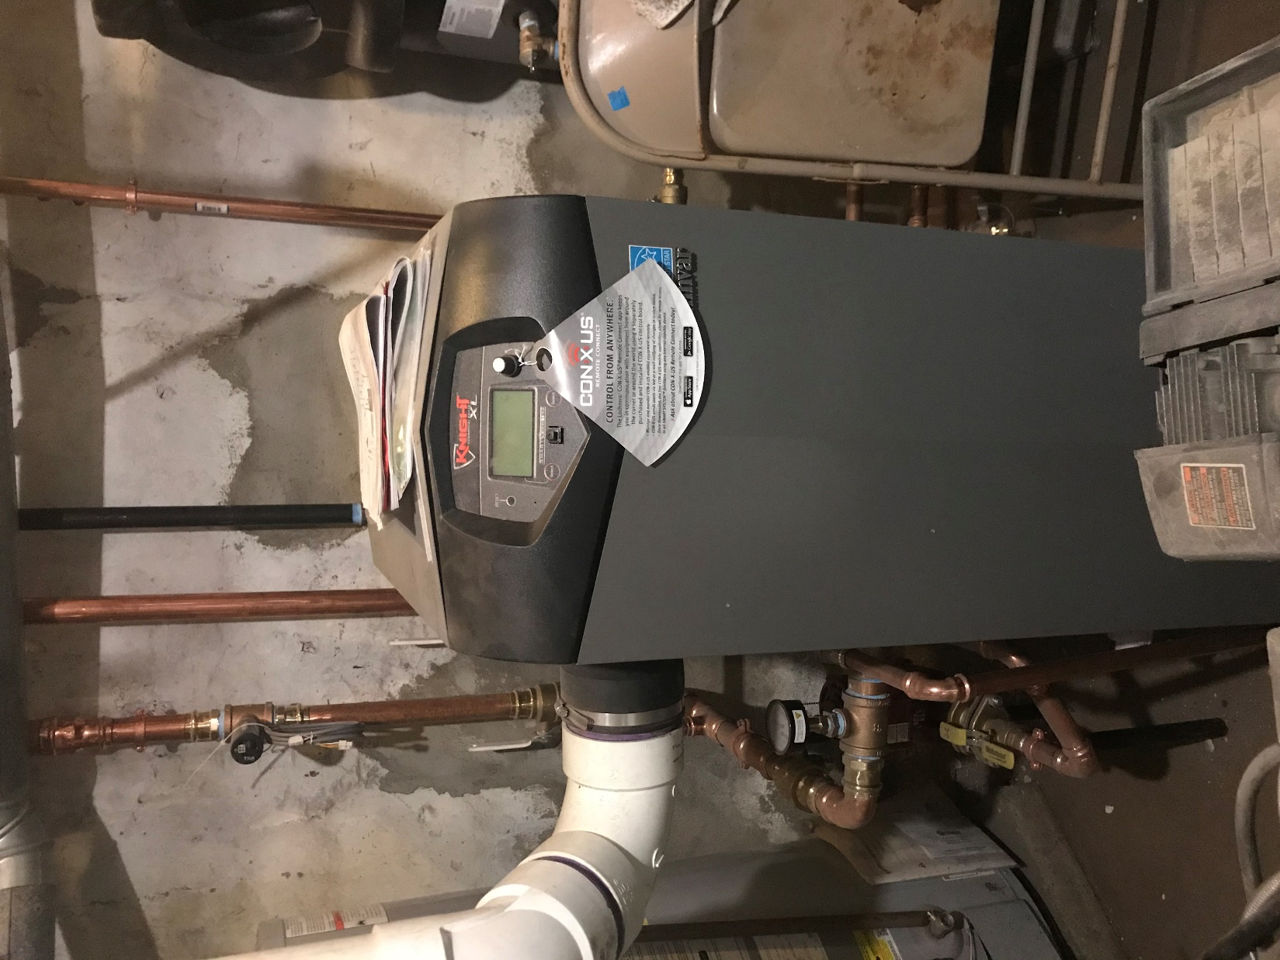
New boiler

