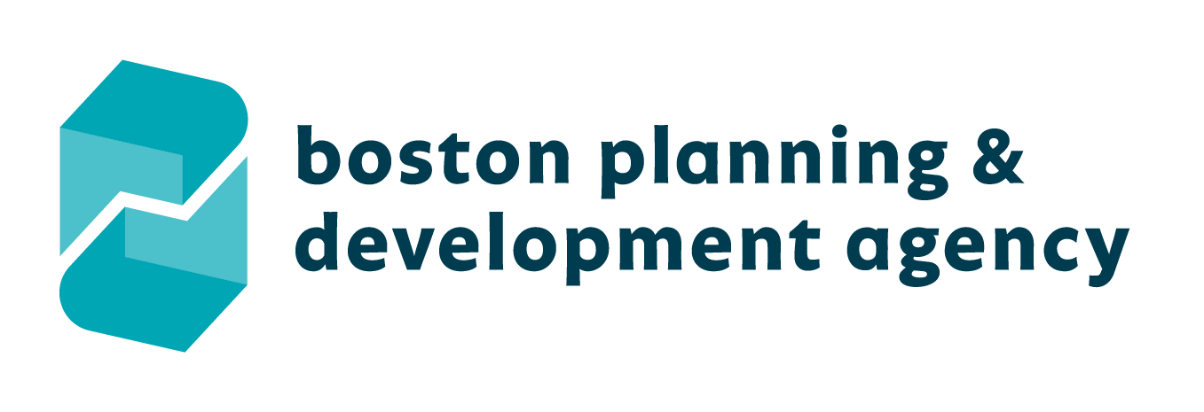

APPLICATION FOR CHILD CARE FUNDS

Applications Due: Friday April 23, 2021 by 5pm

CHILD CARE CONTRIBUTION FUND APPLICATION
On April 15, 1999, the Boston Redevelopment Authority (“BRA”) Board approved the 33 Arch Street project. As part of the 33 Arch Street project, 350 Washington Street LLC agreed to make a child care contribution (“Child Care Contribution”) to create or cause to be created child care facilities. It is anticipated that this contribution will be used to provide child care facilities, which are planned to be located off-site, and/or to expand existing child care services.
Up to $233,774 will be available.
Applicants are required to submit a plan to the Mayor’s Office of Women’s Advancement (MOWA) that describes how the applicant will utilize the Child Care Contribution funds to address the objectives listed below in a manner that will produce the greatest measurable impact on the community. All awards will be subject to BPDA Board authorization and chosen applicants will be required to enter into a grant agreement.
Applicants are required to submit a detailed budget and comprehensive plan describing their objectives and goals if they are to receive funding.
The Mayor’s Office of Women’s Advancement sets forth basic objectives against which the plan and the applicant’s performance under the plan will be evaluated by the Office of Women’s Advancement. The applicant must state how it will pursue these objectives.
Objectives:
- This contribution will be used:
  - to provide child care facilities, and/or
  - to expand existing child care services.
- Applications from varied sources are encouraged, thus project plans from current childcare providers, nonprofit organizations, community stakeholders, and others will be accepted.
- Given the current needs of the childcare market, special considerations will be given to project plans that include a focus on expanding seats for infants, voucher eligible children, and families who need childcare outside of traditional business hours.
- Equitable access to childcare for Boston’s children is a priority of this project. Successful applications will have a clear, sustainable plan to ensure equitable access, including for low-income families and children of color, over time.
- Applications which include cooperative ownership models and/or shared services are strongly encouraged. If applicable, applicants should include a description of the cooperative governance and/or shared services model.
- Competitive applications will also include the ways in which the activity or program strengthens worker pay and provides continuing education for childcare providers.
- Applicants must demonstrate commitment to supporting staff of color and staff from other marginalized communities to move into leadership positions. Commitment may be demonstrated in targeted recruitment, hiring practices, staff development, mentoring, and more.

PROPOSAL CHECKLIST
Applications Are Due: 04/23/2021 by 5pm
As a final step before submitting your application, use this checklist to ensure that your application is complete.
All organizations applying for Child Care Contribution funds must complete and submit ONE ELECTRONIC COPY of the following Child Care Contribution fund documents.
- Completed Application
- Program Budget
- Nonprofit Board of Directors Roster (if applicable)
- Federal Tax Exemption Determination Letter (if applicable)
- Organization Certificate of Good Standing (Provided by the Secretary of the Commonwealth’s Office)
- Such other documentation that the Mayor’s Office of Women’s Advancement may request, if necessary.

Board members must disclose if they, or any immediate family members, are employees of the BPDA and MOWA and may not participate in the review and/or approval of a grant award.
Proposals must be emailed to the below email address. Incomplete, hand-delivered, or mailed applications will not be accepted.
Completed applications and required attachments must be received no later than 04/23/2021 by 5pm. No extensions will be granted.

SUBMIT YOUR ELECTRONIC APPLICATION TO:
Alexandra Valdez
Mayor’s Office of Women’s Advancement
Email: bostonwomen@boston.gov
617-635-3138

APPLICATION PROCEDURES
As designated by the Mayor’s Office of Women’s Advancement, an applicant for Child Care Contribution funds must be a Massachusetts nonprofit corporation, a Massachusetts Department of Early Education and Care licensed child care provider, and/or a local community or civic organization using a Massachusetts nonprofit corporation as its fiscal agent.
If an applicant applies for funds using a local nonprofit corporation as its fiscal agent, an agreement must be signed by the authorized signatories for each organization indicating the relationship between the parties with respect to the application for Child Care Contribution funds. This agreement must be submitted by the application deadline.
In addition, all funded activities must be eligible and meet the objectives set forth by the Mayor’s Office of Women’s Advancement. It is anticipated that this contribution will be used to provide child care facilities, which are planned to be located off-site and/or to expand existing child care services.
Follow the prescribed format for application preparation closely. Present information in the order indicated. Submit all requested information or indicate not applicable (“N/A”) where appropriate. Do not submit materials other than those specifically requested.
If an applicant (a) makes a false statement or misrepresentation in this application to obtain funding or (b) uses the funds inconsistent with the applied for use, the funds and grant agreement may be in default. The Mayor’s Office of Women’s Advancement may declare all or any part of the funds repayable to the Mayor’s Office of Women’s Advancement and the contract voided. The applicant may also be barred from applying for future Child Care Contribution funding.
Please note that some proposals may require City of Boston or other public agency approvals (Public Improvements Commission, Boston Parks Department, etc.). If an applicant is awarded funding for a proposal requiring public agency approvals, disbursement of funding will be contingent upon such approvals. It is incumbent on the applicant to find out if its proposal requires public agency approvals.
Review committee recommendations for funding will be approved by the BPDA Board. A grant agreement will be executed prior to any disbursement of funds.
Recommendations will be based on a variety of factors including specificity and clarity of plan, cost, conformity with the stated objectives, and projected outcomes if funding is awarded.
Successful applicants must provide a written summary of accomplishments, and expenditures, within 90 days after grant completion and submit it to bostonwomen@boston.gov. Applicants may be ineligible for future funding if written summary is not provided in a timely manner.

APPLICATION SUMMARY
Total Amount Requested $ _______________
Applicant Organization Name: _____________________________________________________
Organization Address: _____________________________________________________
City: __________________ Zip: ___________
Contact Person: _____________________________________________________
Title: _____________________________________________________
Telephone Number: _________________________________________________
E-Mail Address: _____________________________________________________
Is Applicant a 501(C)(3) Organization? Yes ____ No _____
Does your organization identify as any of the following:
Minority Led__ Woman Led__ Veteran Led__ Other___________
Federal Employer Identification Number: ____________________

Executive Director: _____________________________________________
Phone Number: ___________________________________
E-Mail Address: ______________________________________________

Board President: ________________________________________________
Phone Number: ___________________________________
E-Mail Address: ________________________________________________

Applications must be authorized and signed by an authorized signatory of the Organization:
Name and Title of Authorized Signatory: _____________________________________________________
Signature of Authorized Signatory: _____________________________________________________
Application continues on next page

PROGRAM DESIGN
1. Describe the specific project to be performed with the Child Care Contribution and how it would provide child care facilities, and/or expand existing child care services. If the project is tied to a particular site or location(s), please specify. (1000 words maximum)

2. Describe the outcomes expected as a result of the proposed Child Care Contribution project (# of seats to be added, jobs created, facility enhancements, strengthening worker pay, etc.). (500 words maximum)

3. List any stakeholders or partners involved in the project and their roles. (250 words maximum)

4. How will this proposed project provide childcare facilities and/or expand childcare services in a way that ensures that low-income children, children of color, and other historically disadvantaged groups have equitable, sustainable access? (500 words maximum)

EXPERIENCE AND EVIDENCE
- Has your organization done childcare work or similar projects before? If so, how long? Describe your organization’s experience in providing childcare related services and/or similar projects for which funding is requested. If you are proposing a new project or program, describe the evidence that informs your model. (500 words maximum)

- If your organization plans to conduct the project in-house, how many staff will work on the project?_____ Describe your staff’s experience in conducting this type of work. Provide a very brief biographical sketch for each staff member who will work with your model in a supervisory role. Please specify whether your organization is a registered as a woman or minority-owned business in the City of Boston or uses a cooperative or shared serviced model. (1000 words maximum)

- If your organization plans to hire a contractor to perform some or all of the work, please name the contractor and describe their specific experience that qualifies them for the project. Please specify whether the contractor is a registered as a woman or minority-owned business in the City of Boston. (1000 words maximum)

- What does “quality childcare” mean to your organization? What evidence or experience informs this perspective? (500 words maximum)

- What does culturally responsive childcare look like in this proposed project? What evidence or experience informs this perspective? (500 words maximum)

BUDGET AND RESOURCES LEVERAGED
1. Include a proposed budget for your project. (Use your own budget form)

2. Please state the requested amount and include a narrative to explain how these funds will be used to successfully implement the proposed Program Design. (1000 words maximum)
_____________________________________________________

Completed applications and required attachments must be received no later than 04/23/2021 by 5pm. No extensions will be granted.

SUBMIT YOUR ELECTRONIC APPLICATION TO:
Alexandra Valdez
Mayor’s Office of Women’s Advancement
Email: bostonwomen@boston.gov
617-635-3138

In 2016 the BRA began doing business as the Boston Planning & Development Agency

