YOUTH CYCLING PROGRAM – SPRING 2017

HOST SITE APPLICATION

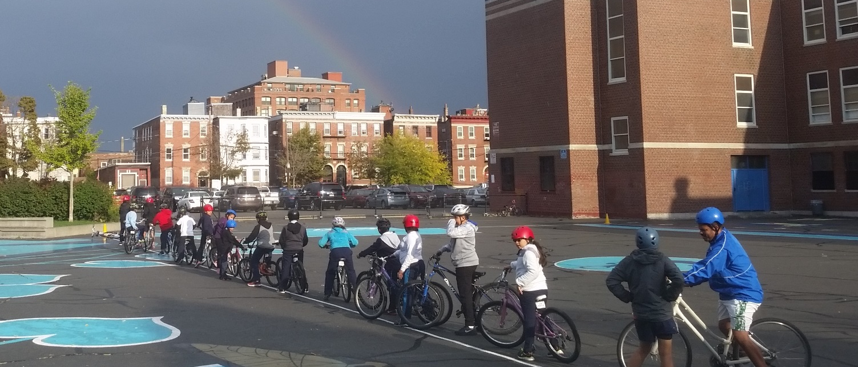
The Youth Cycling Program brings bikes, helmets, instructors, and an active curriculum to Boston Public Schools. We help students from grades 2 to 12 learn bicycle safety through lessons, practice, and having fun. We visit each school for 2 weeks during our spring season. Over 35,000 young Bostonians have participated in the program since 2009.

HOW TO APPLY
Read about our program’s requirements at boston.gov/youth-cycling and prepare your application. You can submit the application:
- Online: Use our online form to complete all the required information and upload any attachments. Complete your application by March 27.
- By email: Return this form to ycp@boston.gov by March 27 with the subject line “Spring YCP – [YOUR SCHOOL NAME]”.
- Mail: If you cannot submit your application using the online form or by email, you can mail it to: Boston Transportation Department ATTN Boston Bikes, 1 City Hall Sq Room 721, Boston MA 02201.

If you have questions or concerns, please feel free to contact us at ycp@boston.gov or 617-635-4156.

OUR ROLE/YOUR ROLE
You will have two Boston Bikes instructors at your school at all times. The instructors will serve as the bicycle experts, sizing your students for helmets and bikes, leading bicycle activities, etc. Teachers serve as the lead in group management, behavior, discipline, and first aid. Our instructors will ask you to help with bicycle activities to help make the program run smoothly. The school host is responsible for distributing information to all participating teachers.

REQUIRED WAIVERS
You will need to distribute and track waivers ahead of our visit so it's clear who is allowed to ride. Waivers (available in English, Spanish, and Chinese) and a customizable parent cover letter will be attached to your confirmation email. They also are available on our program website. Completed waivers should be given to our instructors on the last day of our visit.

YOUTH CYCLING PROGRAM – SPRING 2017

HOST SITE APPLICATION

Visit boston.gov/youth-cycling before completing your application for program requirements
CONTACT INFORMATION  Name:  Your Position:  (e.g., PE Instructor, 3rd Grade Teacher, Principal)  School Phone #:  Cell Phone #:  Email:  Best way to reach you:  school phone cell phone email  Principal: Email:  Yes, the school principal is aware of and supportive of my application. | SCHOOL INFORMATION  Elementary  K-8  Middle School  High School  School/Site name:  Neighborhood:  Address:  School hours:
SESSION PREFERENCE  Please rank your date preferences:  (1 = first choice)  April 24 – May 5  May 8 – May 19  May 22 – June 2  June 5 – June 19 | STUDENT PARTICIPANTS  Participating Grades:  NOTE: We cannot serve a wide grade range in one visit due to bike sizes. We can only serve Grades 2-5 OR 5-8 OR 8-12 in one visit.  How many different classes will participate?  Average class size: Biggest class size:  Over 2 weeks, approx. how many students total do you think will participate in our program?  Participation will be: (check all that apply)  optional required rewarded for a grade  NOTE: Preference is given to schools that offer bike sessions during the entire school day and to a large number of students.

SUPERVISION
We need at least one teacher present with the students at all times. Feel free to invite parent volunteers to help with the program — the more adults to help, the better!

Will you be the teacher present with the students/bikes at all times, or will there be different teachers rotating in throughout the day?

Some students will not be able to participate because of missing waivers, illness, or other reasons. What do you anticipate they will do while the other students are riding bikes?

SCHOOL FACILITIES
Our program requires a safe place for students to ride, sheltered from cars and traffic. We also require a lockable, secure indoor space to store bikes overnight for the duration of the program.

The following space(s) are available for riding sessions:
Open paved recess area (will need to arrange separate bike area during recesses)
Sizeable parking lot without moving cars
Tennis/basketball court where bikes would be allowed
Track where bicycles are allowed
Location within ¼ mile of a bike path, greenway, or park

Describe riding options in detail, if needed:

If riding outdoors is unavailable (e.g., due to rain), is there an indoor space for riding? Yes No

Describe where we can securely store our fleet of 29-35 bikes. A lockable ground floor location, ideally near an exit, is necessary.

On the first day with a class, our instructors will do a classroom-style introductory workshop about biking, helmets, safety, and more. It is ideal for this session to take place in a classroom instead of a gym or outdoors. We start each following session with a short workshop followed by on-bike activities.

BIKE DROP-OFF & PICK-UP
We drop off and pick up bikes at the beginning and end of the session. A lot of coordination goes into moving around the bikes, and we thank you for your patience and flexibility with drop-off and pick-up. We will inform you of your drop off/pick up schedule no less than 2 days ahead.

What are the earliest and latest times for bike drop off/pick up on a Monday? am & pm

What are the earliest and latest times that bike drop off/pick up on a Friday? am & pm

SESSION SCHEDULE
Our program is successful when we work with as many students as possible during our visit. Your schedule should not have large gaps in it. You will need to team up with other teachers/classes in your school to fill these gaps. Ideally, we’ll see each student at least 3-4 times during our visit.

Will we see the same students every day?
Yes No

If no, how many times will we see each class during a 2 week visit?

Our instructors will need a lunch break, but otherwise require a full schedule (minimum of 4 hours of teaching time each day). A schedule with large gaps will not be accepted. Please insert the schedule for our visit below or send it in separately. A customizable schedule (in Excel) is available on our website.

Your schedule:

NOTE: If we do not receive your draft schedule 2 weeks before our visit and a final version 1.5 weeks before our visit, your slot will be filled with another school from the waitlist.

