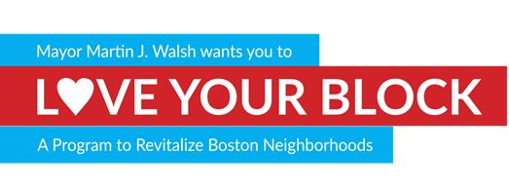
SPONSORSHIP OPPORTUNITIES
Contact Information
Organization: Contact Name and Title:

Contact Phone Number: Contact Email:
Sponsor Level: | Partner | Supporter | Donor
Amount: | >$10,000 | >$5,000 | >$200
Service event for your company
Your logo on Love Your Block Website
Sponsor recognition in local papers
*The hearts correspond with Sponsor Level/Donation Amount and the benefit(s) offered with that donation. All benefits are funded by City Hall and are subject to change.
In Kind Donation(s):
Spades, shovels Soil, woodchips Trees, Flowers Planters
Benches Chairs Paint Other:________
(Please check all that apply)
*In kind donation(s) can substitute monetary donations at equal value
Volunteer?
Individual and group registration can be found at www.boston.gov/loveyourblock
Please return this form to
Kaira Fox
Room 805, One City Hall Square
Boston, MA 02201
Fax: 617-635-3498
Kaira.Fox@boston.gov

